**INTERNET AND WEB PROGRAMMING**

**J COMPONENT**



**VentureHome** An online shopping stop for all your housing needs

# **TEAM DETAILS**

20BCI0081 DIVYANSH SING

20BCE2166 ANUJ SINHA

20BCE2495 GONA ANUDEEP SIMHA REDDY

## **Abstract**

The project aims to create an online shopping site that deals with furniture and related items. The site will be a simple and clean looking one with easy-to-use interface.

## **modules**

The modules include:

* Front Page – The Front Page of the site to welcome users
* Products Page – Page with list of products
* Product Page – Page containing product information
* Sign In Page – Page for Sign In
* Sign Up Page – Page for Signing Up
* Check-Out Page – Page for checking out

## **screenshots:**

## **Home page:**

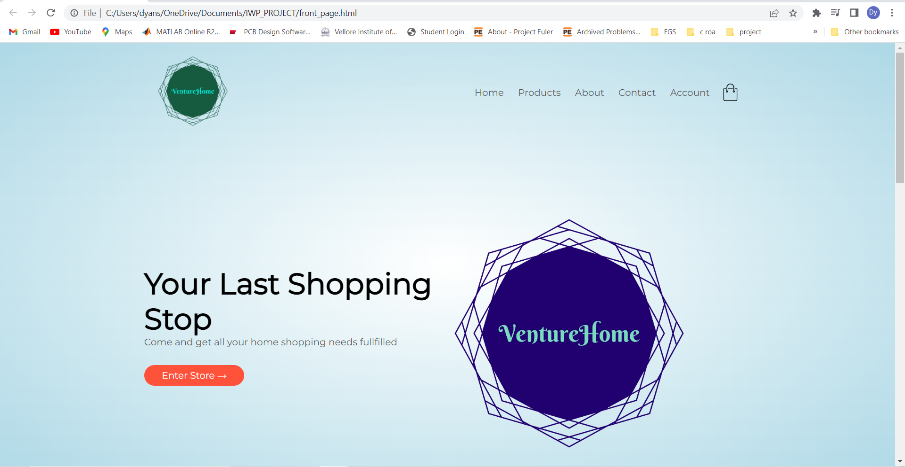

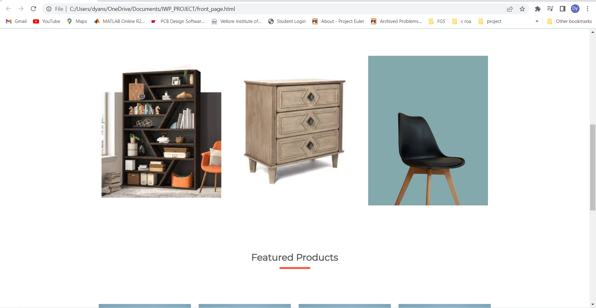

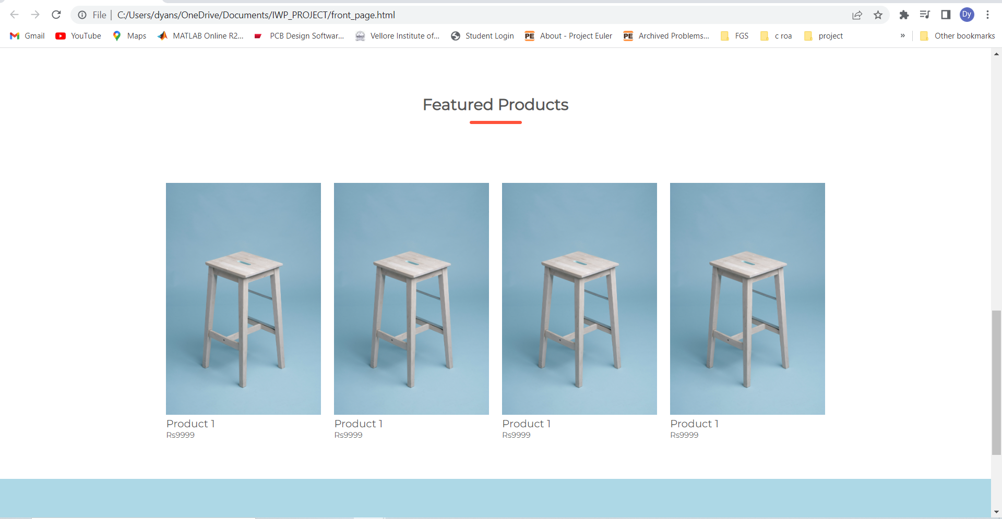

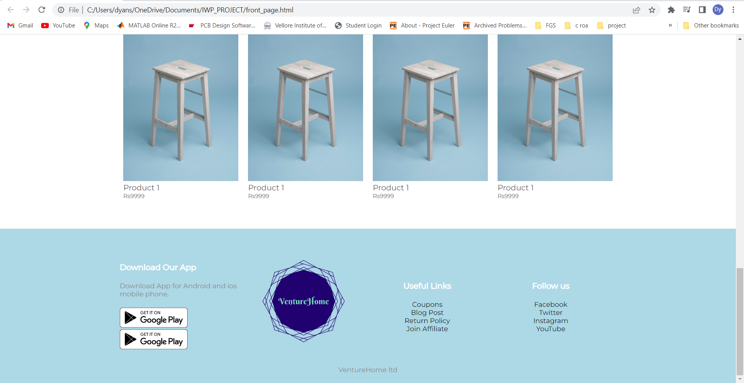

## **all PRODUCTs page:**

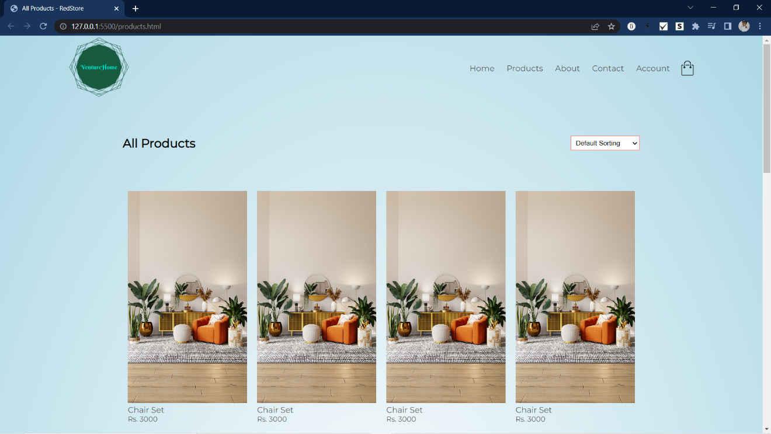

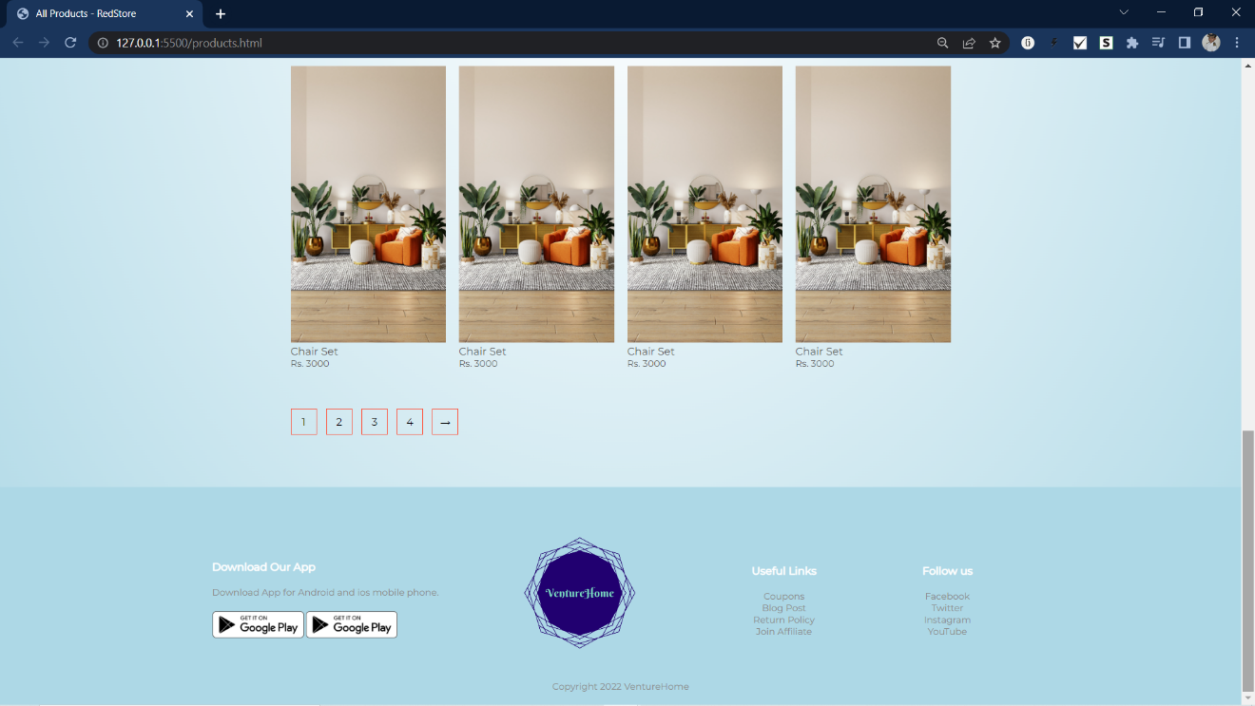

## 

## **PRODUCT’s DESCRIPTION page:**

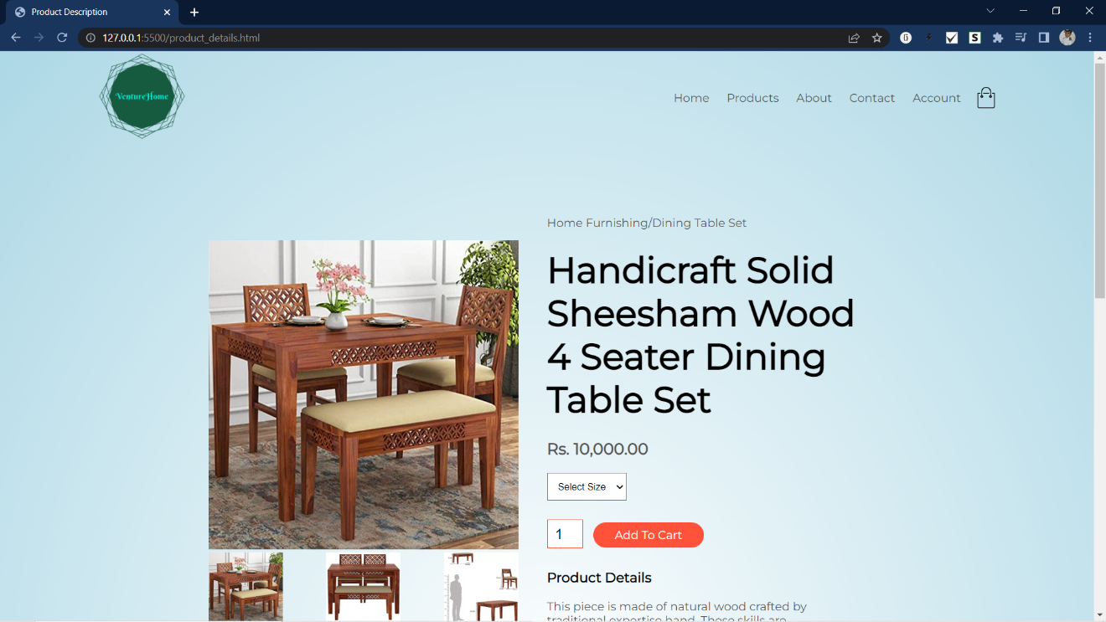

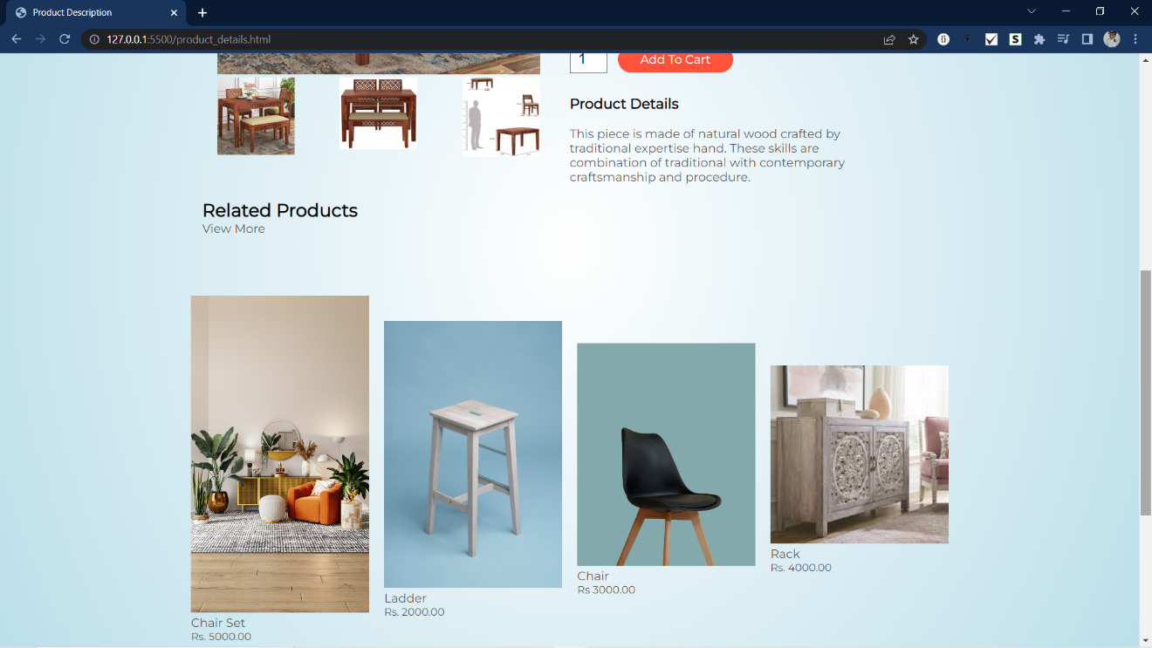

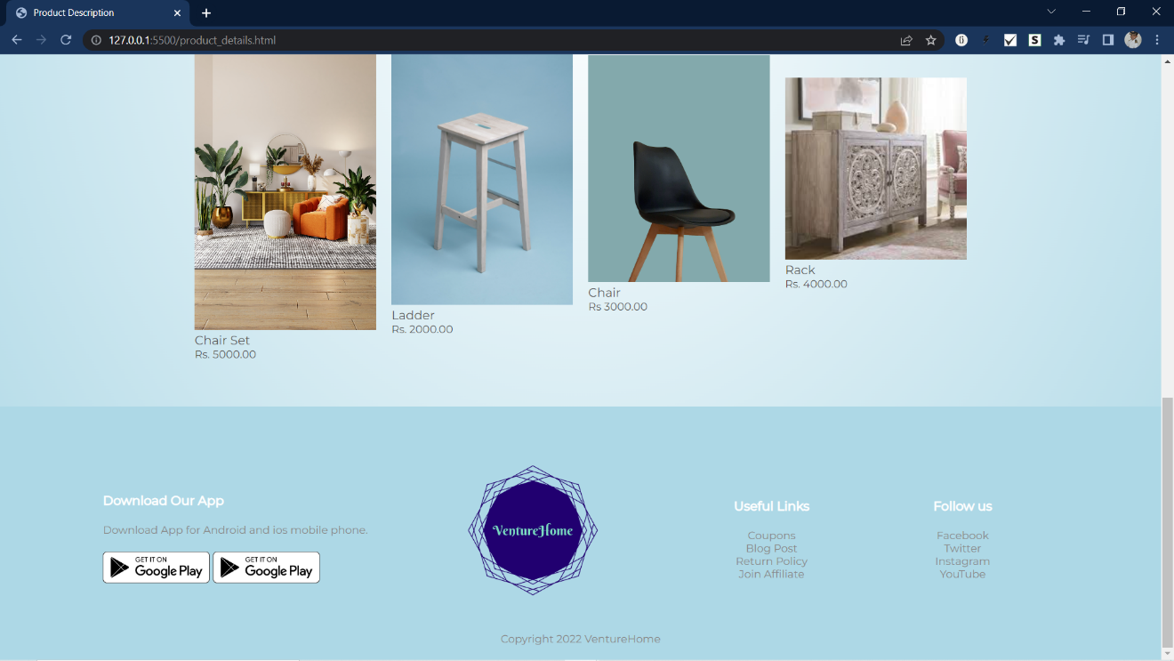

## **LOGIN/REGISTER PAGE:**

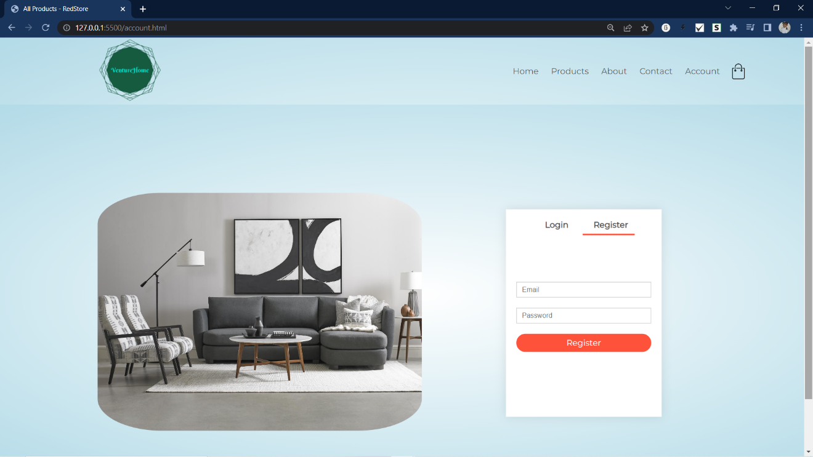

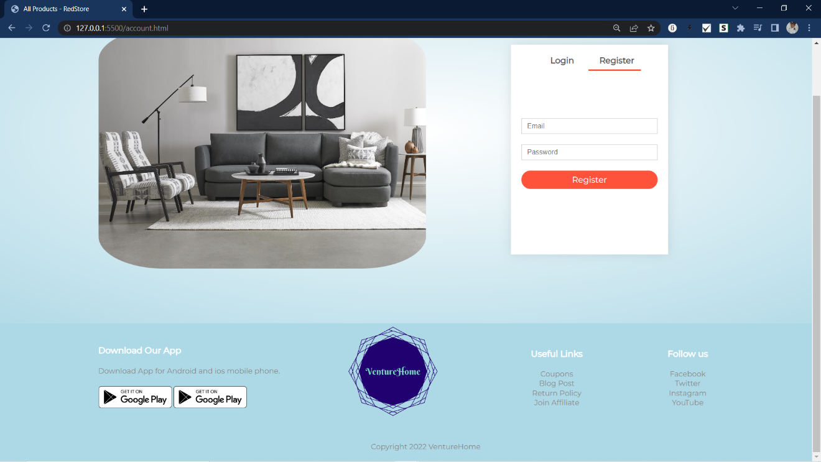

## **CHECKOUT Page:­**

